Homemade Chicken Noodle Soup
Prep Time:
10 Minutes

Cook Time:
1 Hour

Difficulty:
Easy

Servings:
6
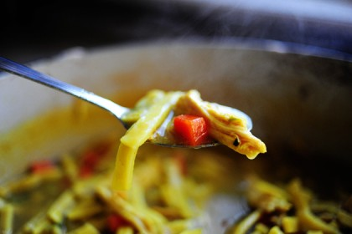

Ingredients
- 1 whole Cut Up Fryer Chicken
- 2 whole Carrots, Diced
- 2 stalks Celery, Diced
- 1/2 whole Medium Onion, Diced (optional)
- 1 teaspoon Salt
- 1/2 teaspoon Turmeric
- 1/4 teaspoon White Pepper (more To Taste)
- 1/4 teaspoon Ground Thyme
- 2 teaspoons Parsley Flakes
- 16 ounces, weight Reames Frozen "homemade" Egg Noodles

Preparation Instructions
Cover chicken in 4 quarts water. Bring to a boil, then reduce heat to low. Simmer for 30 minutes.
Remove chicken from pot with a slotted spoon. With two forks, remove as much meat from the bones as you can, slightly shredding meat in the process. Return bones to broth and simmer on low, covered, for 45 minutes.
Remove bones from broth with a slotted spoon, making sure to get any small bones that might have detached.
Add the carrots and celery (and onions, if using) to the pot, followed by the herbs and spices. Stir to combine and simmer for ten minutes to meld flavors.
Increase heat and add frozen egg noodles and chicken. Cook for 8 to 10 minutes.

